Gender Roles
The court of Copenhagen are calling for the following men and women to be arrested.
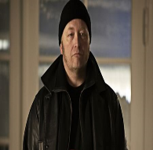
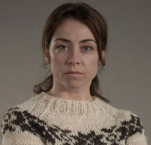
Rie Skovgaard

Jan Meyer

Pernille Birk Larsen

Troels Hartmann

Theis Birk Larsen

Sarah Lund

They are suspected of not conforming to their gendered roles.

Gender Role Stereotypes
The correct way for women and men to behave– as set out by the government of Denmark. Guidelines that both men and women should follow include but are not limited to:
Men
- Cold and heartless
- Unfaithful
- Rational
- Work orientated/breadwinner
- Harsh
- Active – makes all of the decisions
- Strong
- Rough
Women
- Caring
- Nurturing
- Irrational
- Domestic
- Sensitive
- Fragile
- Passive
- Sexual object
Courtroom practices
- The opposition must begin by stating a case against the defendants.
- The defendants will then have a chance to address any accusations or evidence given to them. Therefore they must be ready for the accusations in order to be prepared with a defence case.
- The cycle continues until a verdict is reached. A verdict will be reached if there is no longer any accusations to be made without evidence to suggest otherwise or disprove of it. Contrary a verdict can also be reached if there is overwhelming evidence that cannot be defended.
Opposition (find evidence which subverts) | Defence (find evidence which conforms)
Tom  Gabriel  Cane  Jade  Zoe  Mia  Kameron  Jennifer  Destiny  Maisie  Hannah J | Fred  Liam  Hannah H  Beatriz  Megan  Tia  Hannah W  Alana  Ingrid  Bliss  Dominika

Evidence to support the accusation: | Evidence to defend against the  accusation:

