Spectre Website Analysis Homework
Answer all of the questions below. Each answer will be used as evidence in the first exam in June. Specifically for question 3a-3d. The questions will prompt you to look for evidence that supports the following arguments:
1. Spectre received a high budged and therefore were able to produce a successful film.
2. The ownership behind Spectre are conglomerates who had the ability to distribute and market the film strongly.
3. EON spent a lot of money on the marketing, production and distribution of Spectre, which ultimately enabled it to be successful in box office.

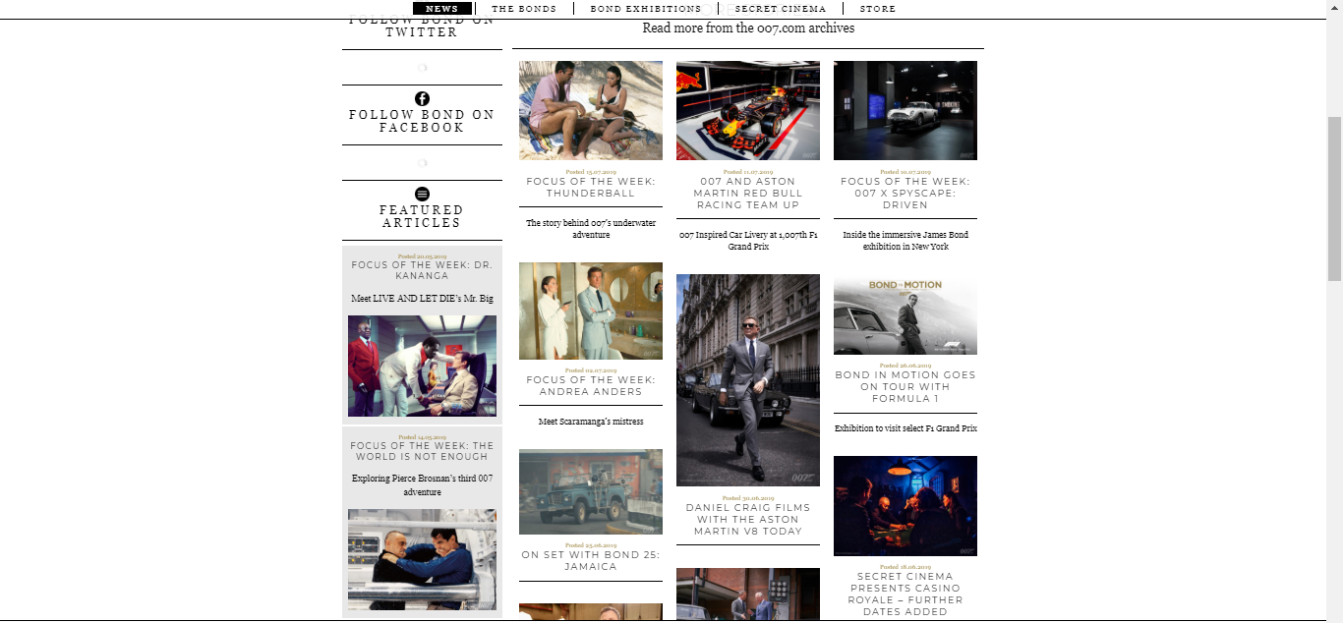

Screenshot of the homepage to 007 website.

1. What examples of above and below the line advertising can you see on the screenshot above?

2. What are the benefits of being able to advertise using both above and below the line advertising?

3. What examples of product placement and synergy can you see on the screenshot above?

4. What are the benefits of using product placement and synergy?

5. What methods of distribution do you see on the screenshot above?

6. What examples of high quality production can be seen on the screenshot?

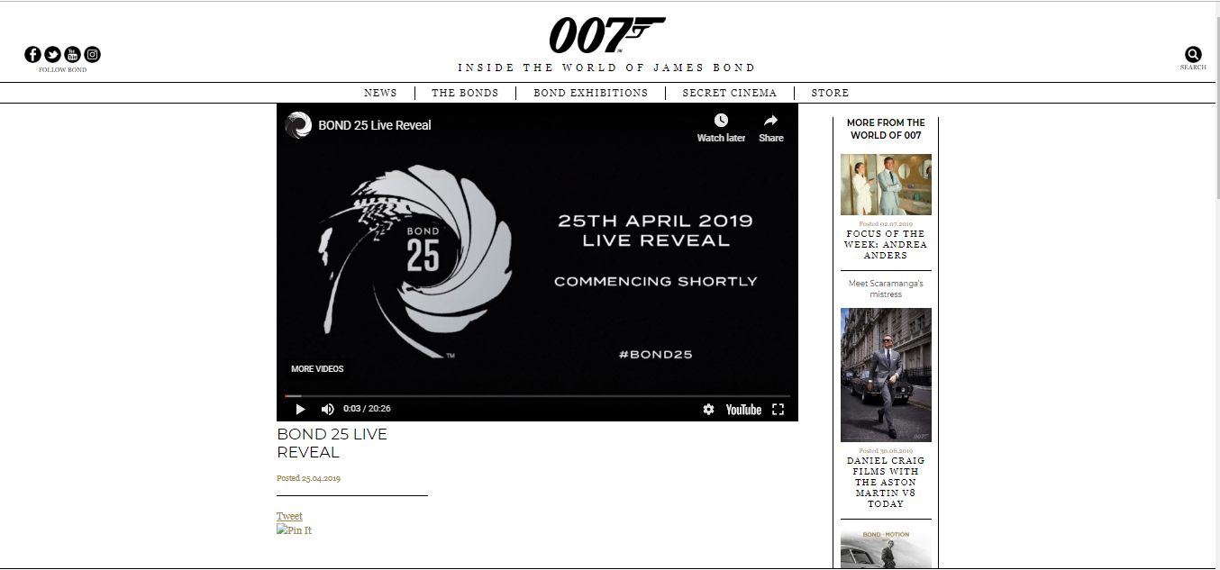

Screenshot of the live reveal of Bond 25 page.
https://www.007.com/bond-25-live-real/

Visit the website page (see link above) and answer the questions below.
1. Why do you think EON Productions produced a live reveal video?

2. What are the risks of broadcasting live?

3. What are the benefits of broadcasting live?

4. What information did fans receive during the broadcast?

5. What information was withheld from the fans during the broadcast? What do you think fans would have liked to hear or see?

6. Did the fans have a negative or positive response to the broadcast? Check the comments section.

7. Why was EON able to produce a live broadcast?

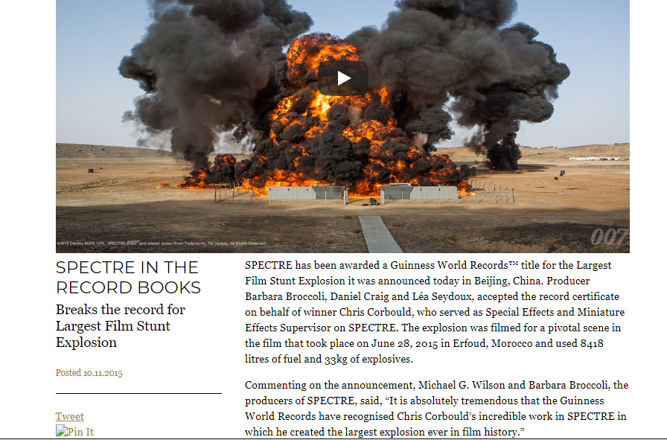

Screenshot of the page detailing the footage of the largest explosion filmed (Spectre).
https://www.007.com/spectre-in-the-record-books/

Visit the website page (see link above) and answer the questions below.
1. Explain why EON would want to advertise the Guinness World Record title of largest film stunt explosion on their website.

2. The explosion would have taken a large chunk of the production budget up. Why would EON want to have such a large explosion featured in their film?

3. The explosion was a once only occasion and had to be filmed in one take. What are the risks of this, and why would non-conglomerate companies not have been more readily able to take them?

