Conglomerate

Global Audience

Funding

Pre-Production

Development

Component: 1B

Unit: Film - Spectre

Area: Industry

Regulation

Convergence

Production

Post-Production

Above the Line Marketing

Distribution

Digital Technology / Platforms

Below the Line Marketing

**Knowledge Organizer Glossary**

**Conglomerate:** A large company that owns other companies that have been both horizontally and vertically integrated.

**Development:** Ideas are created and if necessary rights are bought. Screenplay is written and financing is sought.

**Pre-Production:** Cast and film crew are found, locations chosen and sets are built.

**Production:** The film/product is filmed, recorded and made.

**Post-Production:** The recorded footage/sounds are edited. Crew work on the sound, images and visual effects.

**Distribution:** The finished product is distributed to customers. It can be screened at home or at the cinema.

**Regulation:** External third party companies that enforce rules onto the media. They deal with customer complaints and apply appropriate age certifications to products.

**Above the line Marketing:** Expensive advertisements such as TV spots, Billboard Posters and Radio advertisements.

**Below the line Marketing:** Cheap advertisements such as social media posts, news reports and word of mouth.

**Funding:** The money used on the production, distribution and marketing of a product.

**Digital Technology / Platforms:** The devices used to view/use a media product on that have access to the internet.

**Convergence:** The coming together of media on one device (such as smart phones).

**Conglomerate Example**

Regulation

**Film – BBFC (British Board of Film Certification)**

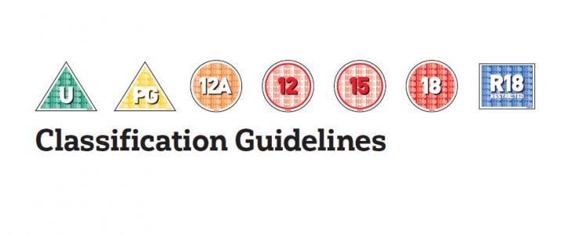

**Video Gaming – VSC (Video Standards Council) & PEGI**

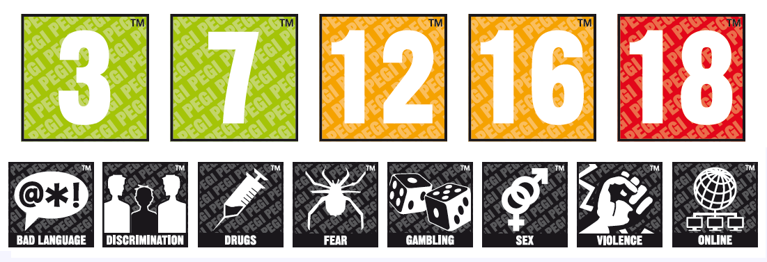

**Radio – OFCOM: Deals with complaints from the public.**

**Websites – unregulated!**



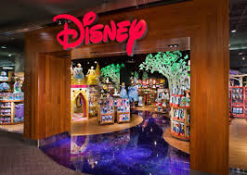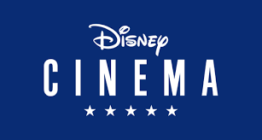C:\Users\tprior\AppData\Local\Microsoft\Windows\INetCache\Content.MSO\AD007141.tmp

Funding & Types of ownership

**Government Funded:** The government help to fund the channel or product.

**Commercially Funded:** The product is funded by the profits made from previous products.

**Not-For-Profit Companies (Charity):** The product is funded via donations and/or the government.

Production Process

Convergence

