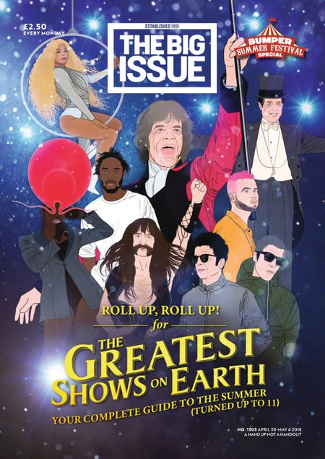
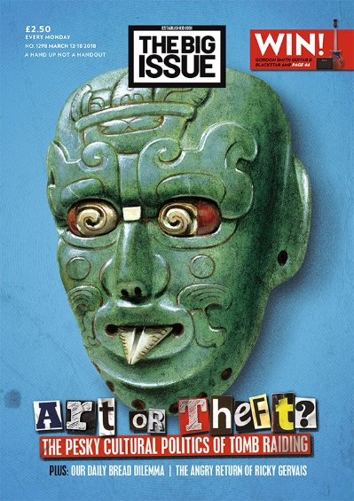
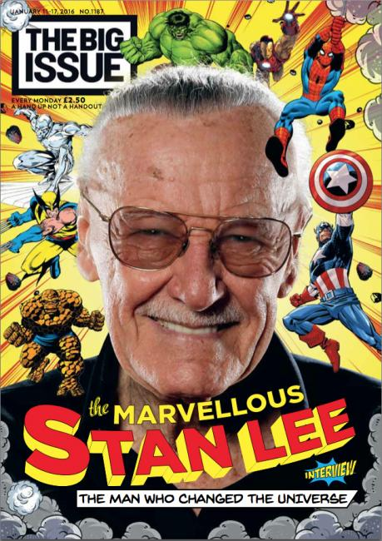
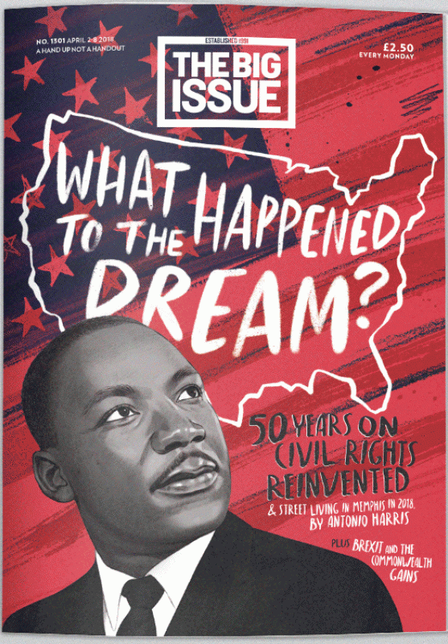
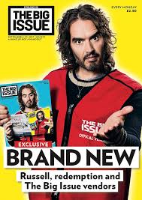
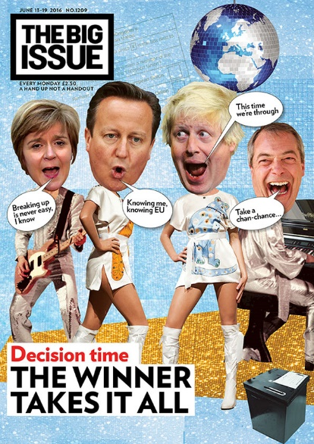
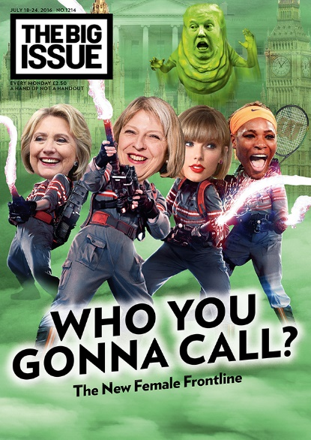
Fig 1.

This text needs to be revised in regards to:
- Media Language (semiotic analysis & genre)
- Representation (how males and race are represented)
- Social and Cultural Context (how the outside world influences the creation of the product, and vice versa).
If magazines come up in the exam – you will be asked to analyse an UNSEEN front cover of The Big Issue!
Practice Questions
Analyse why The Big Issue magazine has used an intertextual approach to the referendum on its front cover. Refer to fig 1.
In your answer you must:
• Analyse the use of intertextuality to create meaning in the source
• make judgements and reach a conclusion about the advantages of this use of intertextuality to The Big Issue magazine. [15]

Discuss the ideological positioning of the front of The Big Issue fig 2.
In your answer you must:
• Analyse Bathes and Hall’s media language and representation theory
• Make judgements and reach a conclusion using Curran & Seaton in your response. [15]

Explain how the representations in magazines reflect their contexts. Refer to The Big Issue covers you have studied to support your answer.
Analyse why The Big Issue magazine has used an intertextual approach to Brexit on its front cover.
In your answer you must: Analyse the use of intertextuality to create meaning in the source. Make judgements and reach a conclusion about the advantages of this use of intertextuality to The Big Issue Magazine.

Media Language Revision Questions
- Analyse how a combination of elements (layout/language/image/content) have created meaning using semiotics.
Date: Every Monday
Price £2.50
Masthead written in bold capitals

Sell line “A hand up not a handout”

Central main image featuring Russel Brand

Brand wearing a Big Issue Vest.
Russel Brand holding other Big Issues with himself on the front cover

One main coverline “BRAND NEW…”
Bright yellow background

- What are the generic conventions of the media form (magazines) and how does The Big Issue conform/subvert these conventions? (refer to the other examples above).

- How does the media language incorporate viewpoints and ideologies?

- What are the intertextual examples related to The Big Issue?

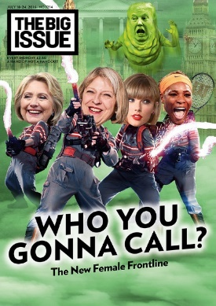
Representation Revision Questions

- How does selection and combination create representations of gender and politics on The Big Issue?

- How does the set text seemingly create a sense of realism and construct a version of reality?

- Analyse and explain the impact of social, political and cultural contexts on how producers choose to represent groups of people and places in the set text.

- Analyse and explain positive and negative uses of stereotyping.

- Analyse and explain how representations may invoke discourses and ideologies and position audiences to act/think in a certain way.

