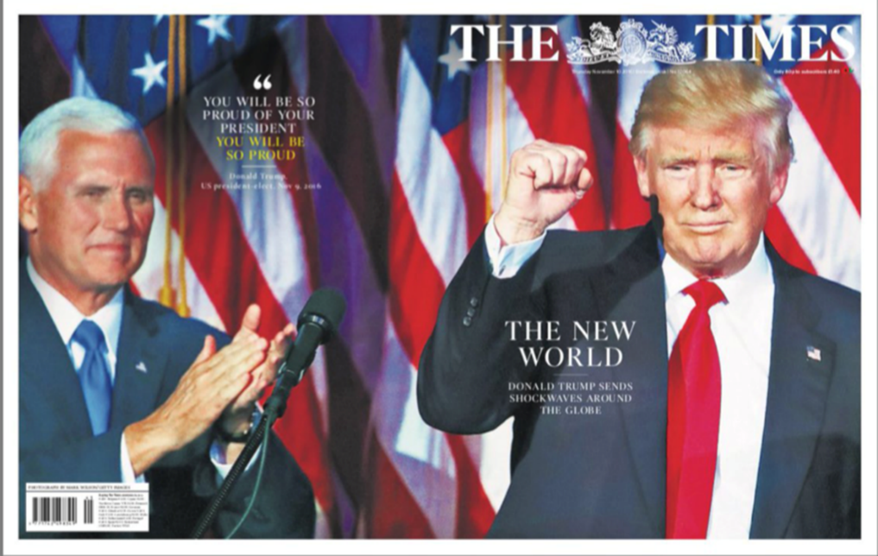

**Stuart Hall Reception Theory**

What would be the preferred/dominant reading of this text? Who would have the preferred/dominant reading of this text?

What would the negotiated reading of this text be? Who would have a negotiated reading of the text?

What would an oppositional reading of the text be? Who would have an oppositional reading?

**Clay Shirky End of Audience Theory**

*The conceptualisation of audience members as passive consumers is no longer tenable in the age of the internet with the rise of the prosumer who can create their own content such as submitting stories and being part of forums.*

The Times is a subscription only service… What does this imply? What impact could this have on its readership in a modern world of free content?

Were there any comments or forums on The Times’ website regarding the Presidential Election? What did they say? Were they overly supportive or similar to the messages given by The Times?

How else were the readership of The Times able to communicate, interact or prosume in regards to the Presidential Election campaign topic?

**George Gerbner Cultivation Theory**

*Exposure to repeated patterns of representation (of Trump and his election campaign) by newspapers can shape and influence audience’s views and opinions.*

Research:

Other front pages or articles from The Times on the American Election topic. Screenshot and print small pictures to include here.

Explain what the various messages, viewpoints and ideologies were on the front pages/articles regarding Trump & Clinton:

How would that cultivate the minds of the readers?