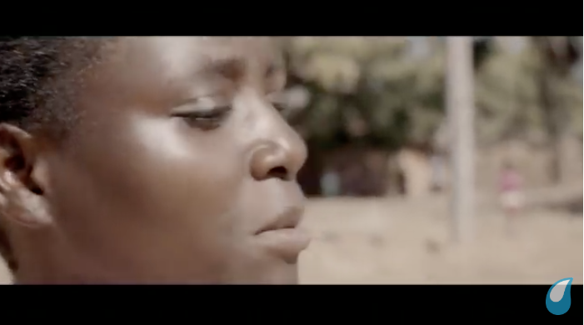

**How are the audience positioned by the representations in the WaterAid advert? (30 marks)**

Audience positioning

Representation in the advert?

How is it constructed? Discuss technical codes (MES, sound, editing, cinematography)

Audience positioning

How is it constructed? Discuss technical codes (MES, sound, editing, cinematography)

Representation in the advert?

Representation in the advert?

How is it constructed? Discuss technical codes (MES, sound, editing, cinematography)

Audience positioning

Dominant ideologies, stereotypical, subverts, conforms, audience position, demographic, traditionally, live aid, conventional, unconventional, core messages, constructed, diegetic sound, non-diegetic sound, binary opositions, codes, slow-paced, fast-paced, non-stereotypical, re-presentation, cultural spheres, van zoonen, stuart hall, Gauntlett, Gilroy, post-colonial perspective, original, roles of women, proxemics, intertextuality