GCSE Media Studies – Set Product Fact Sheet

Component 1: Exploring the Media

Focus areas:
- Media Contexts
- Media Industries
- Audiences
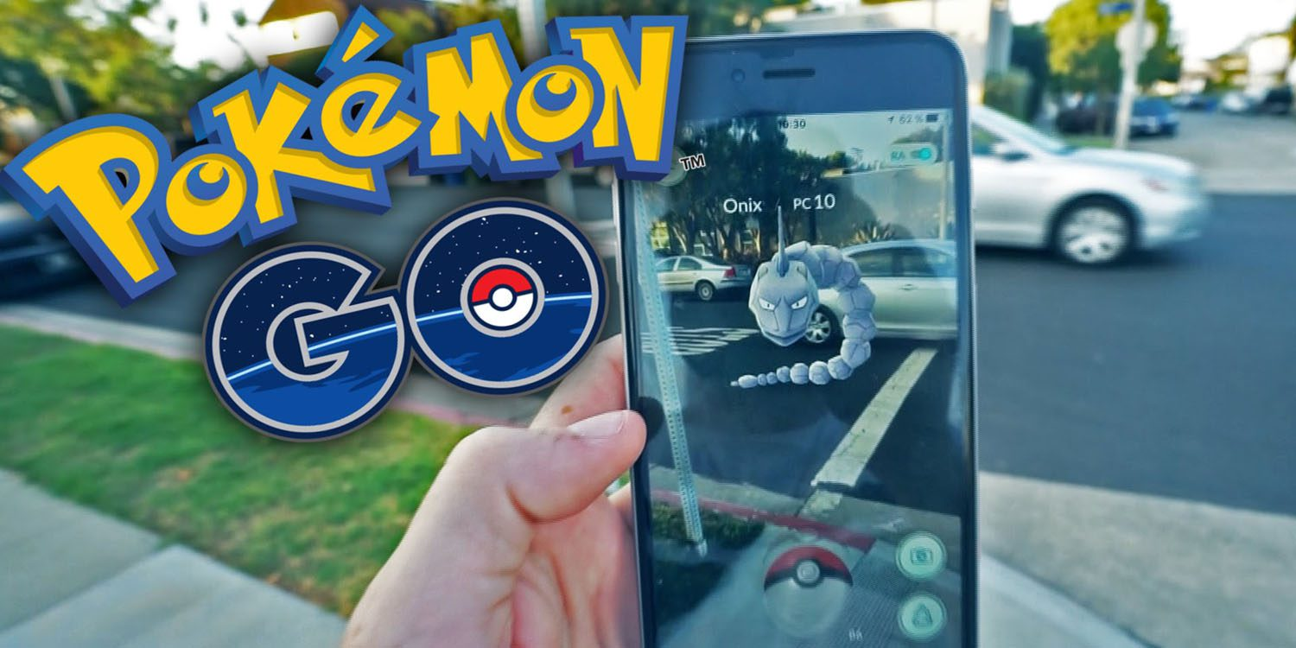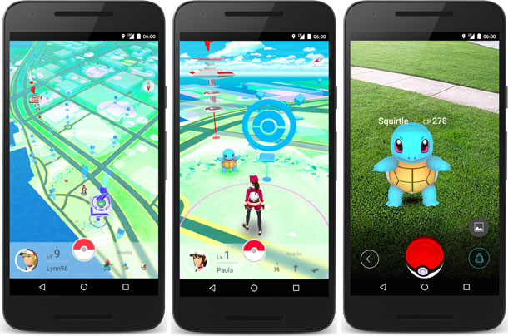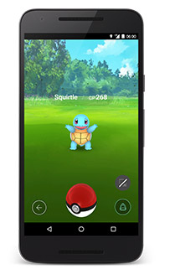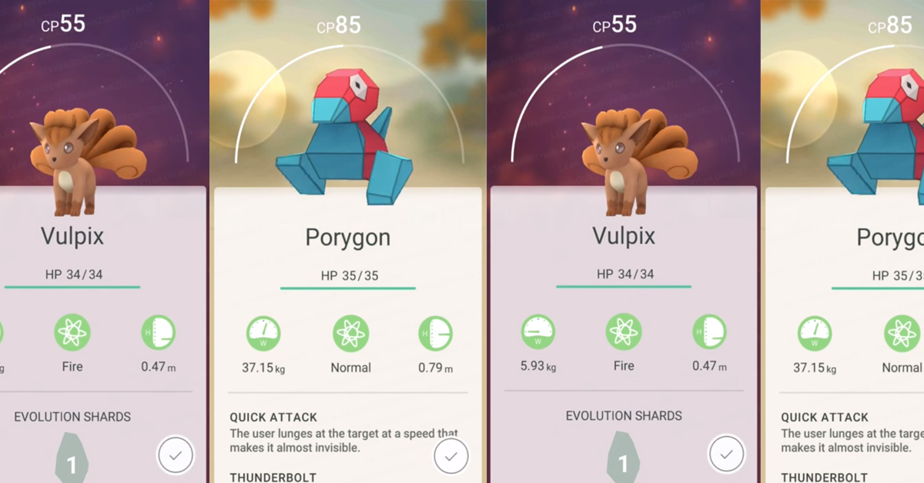

Video Games
- Pokémon Go 2016
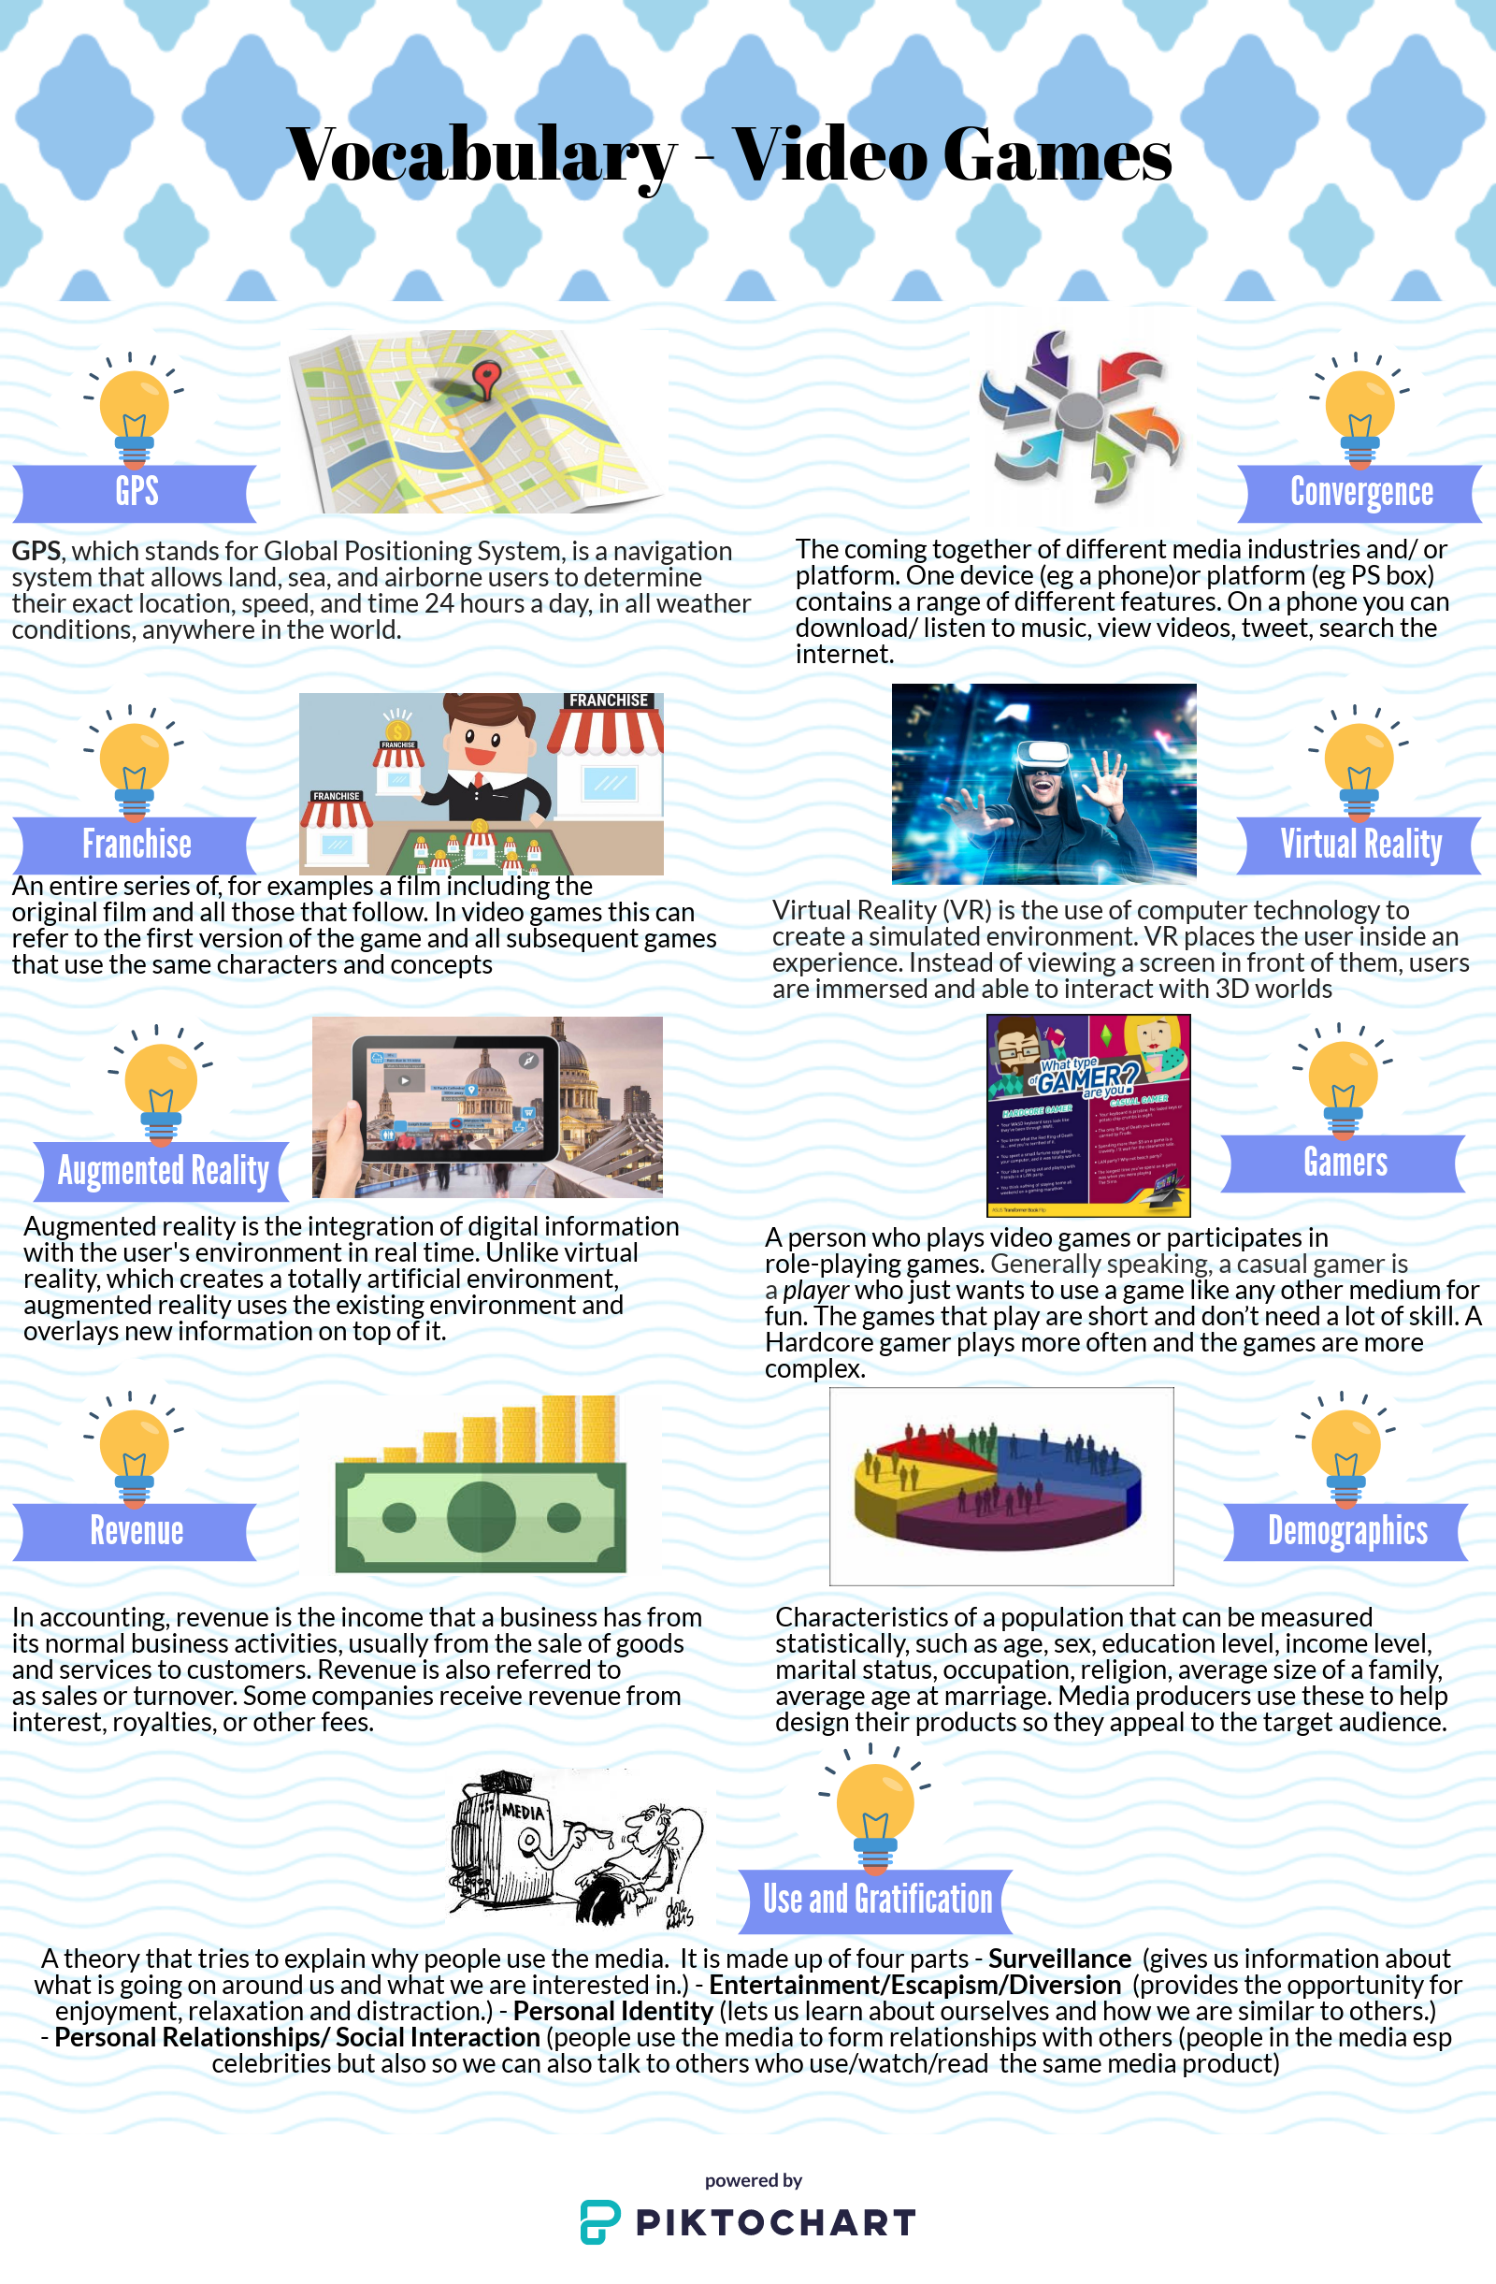
Production Context
Key information about Pokémon Go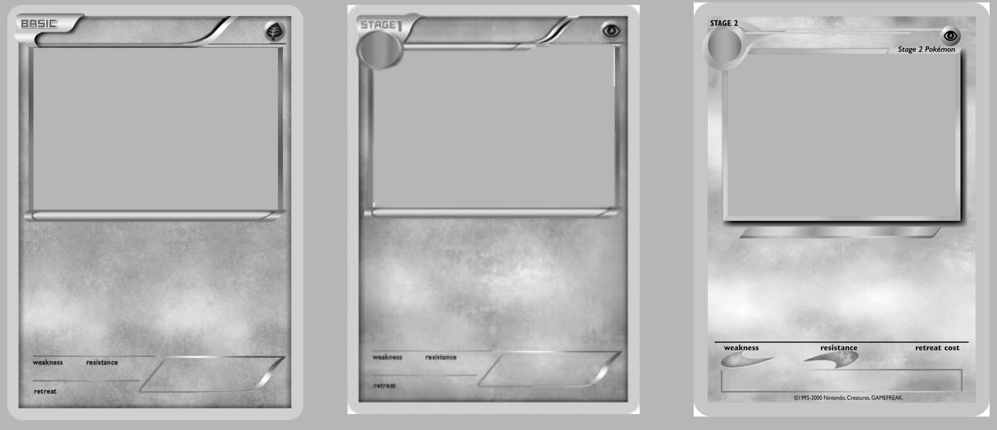

Cultural Context
The Pokémon World
Pokémon Go (2016)
The Video Game Industry
Funding

Revenue
Regulations:
Franchise
Technology & Convergence:
Pokémon Go (2016)
Audiences
Target audience:
Explain what demographics are in your own words

Who was the original target audience for Pokémon Go?

Who is now the target audience of Pokémon Go?

Why is it important that you know who your target audience is?

Use and Gratification Theory:
Social and Cultural Issues:

