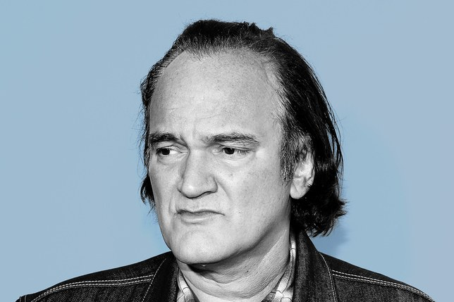

**List of Tarantino Films**

**Overview of Tarantino’s Life**

**Quentin Tarantino**

**Auteur style** – *independent research* - What traits to we expect to see in a ‘Tarantino’ film?

*Is his style and particularly* ***Pulp Fiction****,* ***post-modern****?*