Regency characters wearing upper class and fancy outfits.

(Rule of thirds) Top third features Major Quality and Miss Sweetly looking down at the characters.

Middle Third features middle class people enjoying lots of sweets and dressed respectfully at home.

Bottom third contains information and pictures of the product, with a white border/background.

**Golden frame centred above the man and over his head.**

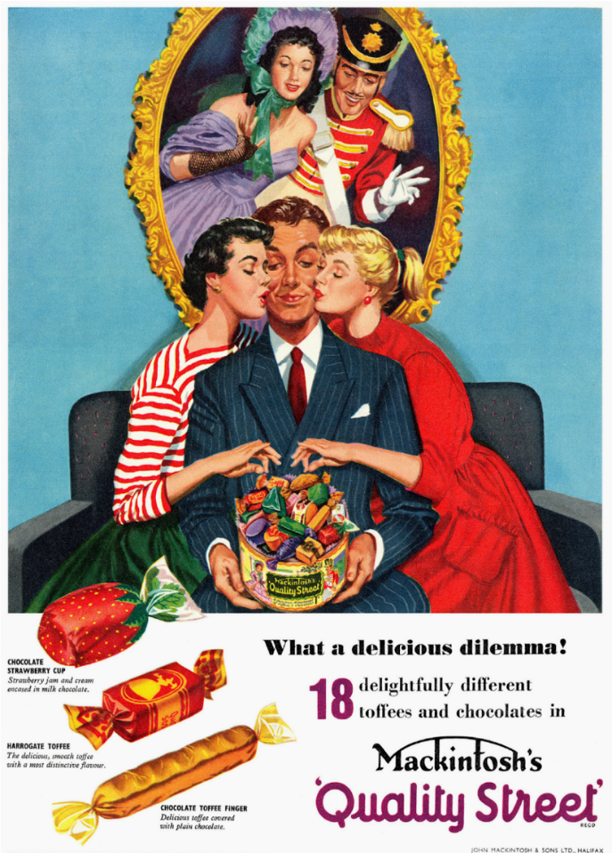

Male choosing between two women. With the sweets on his lap, females choosing which sweet to eat.

**Man wearing a business suit. Women wearing red, white and green outfits.**

Phallic symbolism by placing the tin above the man’s crotch whilst the women are kissing him on the cheek.

The words “Delicious Dilemma!” – Where do we see examples of a dilemma? What does that suggest?

Alliteration “Delicious Dilemma!” and “Delightfully different”

Superlative “Delicious” and “Delightful”

The word “Quality” in “Quality Street”.

Enlargement of the sweets.

Hand-drawn and artistic nature of the design, with a rich colour palette (pastel colours, bright colours, purples and pinstripes etc.).

**Serif and purple typography “Quality Street”**