The Guardian
15 January 2019

Brexit Deal

https://www.theguardian.com/politics/2019/jan/14/may-makes-final-case-for-brexit-deal-dont-let-the-people-down

Trump and Russia

https://www.theguardian.com/us-news/2019/jan/14/trump-mueller-russia-investigation-william-barr
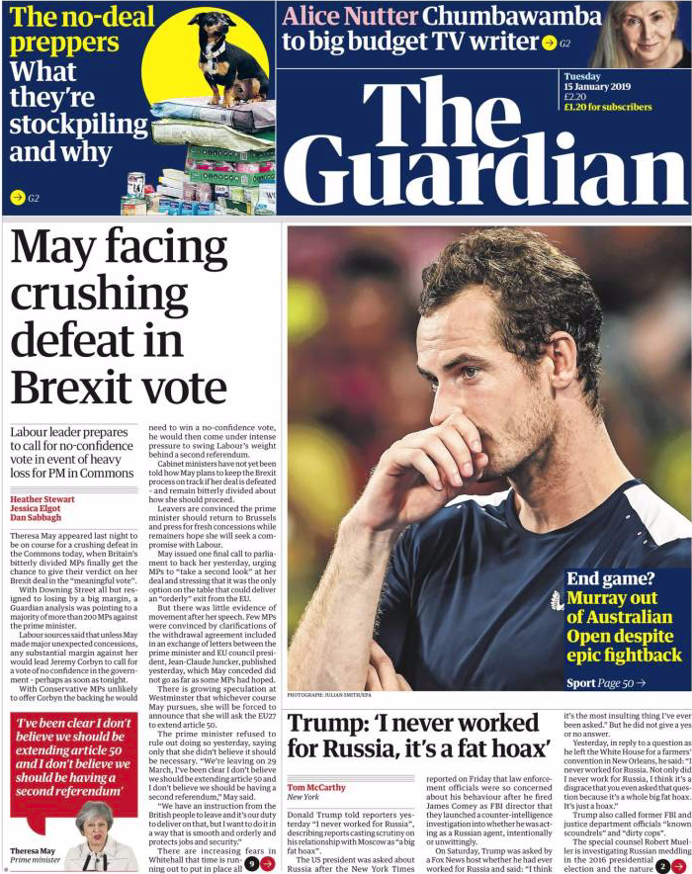

Daily Mail
15 January 2019
Main link
https://www.dailymail.co.uk/home/index.html

Brexit Deal
https://www.dailymail.co.uk/news/article-6592903/PM-faces-crushing-Brexit-defeat-vote-no-confidence.html
