Butch

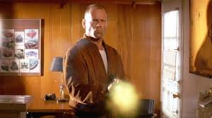

Scene:

Vince
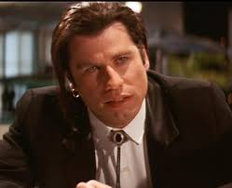

Scene:
Butch

Scene
Vince

Scene:
Which of the two characters draws more of a response from the spectator?

Character How do you develop a relationship with the character

