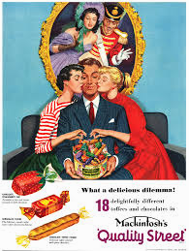

Where do the leading lines lead the audience’s eyes to?

How do the leading lines add to the idea that the man is in control?

What other evidence is there to suggest that the man is the patriarch of the household?

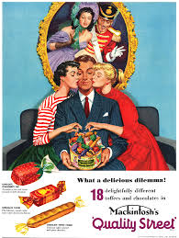

**Explain with the use of evidence why Laura Mulvey would be unhappy by the sight of this print advertisement.**

**Use the prompt words below!**

1. **Phallic Symbolism**
2. **Businessman**
3. **Stereotypes**
4. **Subservient**
5. **Romance**
6. **Manipulation**
7. **‘Prize’**
8. **Feminine**

Phallic Symbolism

Businessman

Stereotypes

Subservient & Romance

Manipulation & ‘Prize’

Feminine